**Experiment 5**

**PART A**

|  |  |
| --- | --- |
| **Roll. No. : A016, A018, A022** | **Name: Varun, Simran, Kartik** |
| **Sem/Year : Btech CSBS** | **Batch:1** |
| **Date of Experiment :9/23/2022** | **Date of Submission:9/23/2022** |
| **Grade --** |  |

**A.1 Aim**

*To perform User Research for a given problem. (an application /website)*

**A.2 Prerequisite**

An understanding of how to conduct the various user research techniques like interviewing, contextual inquiries, competitive analysis etc.

**A.3 Outcome**

After experimentation, students will be able:

* To carry out various user research methods efficiently.
* To conduct contextual inquiries and interview sessions to identify the problems of the users.
* To perform a comparative analysis of at least 3-5 dominant competitors to your product/service in the market.
* To gather user frustrations, challenges, needs and expectations from the solution.
* To show that how we can overcome problems according to user needs.

**A.4 Theory**

User research is the methodic study of target users—including their needs and pain points—so designers have the sharpest possible insights to work with to make the best designs.

User researchers use various methods to expose problems and design opportunities, and find crucial information to use in their design process.

Examples include user interviews, focus groups, contextual inquiries, and competitive analysis.

It's important to use a mixture of both quantitative and qualitative methods to come to a holistic understanding of the user and problems to be solved.

**A.5 Tasks to perform**

* 1. Visit the following link for understanding user research methodology.

<https://medium.com/@megmcneilly/case-study-connecting-hotel-guests-and-the-value-of-contextual-observations-8350390cb0f3>

[https://blog.prototypr.io/bringing-the-artys-store-experience-online-a-ux-case-study-36ecad498cb3https://blog.prototypr.io/bringing-the-artys-store-experience-online-a-ux-case-study-36ecad498cb3](https://blog.prototypr.io/bringing-the-artys-store-experience-online-a-ux-case-study-36ecad498cb3)

* 1. Conduct User interviews using following guidelines:
  + Set a goal for the interview (What you want to learn)
  + Selecting representative participants to talk to.
  + Select a skilled interviewer who knows how to make interviewees feel more comfortable, asks questions in a neutral manner, listens well, and knows when and how to probe for more details
  + Make the user feel as comfortable as possible. Create a rapport with the user.
  + Prepare questions before the interview.
  + Anticipate different responses, and construct follow up questions based on your research goals.
  + Getting permission to tape the sessions and have one or more note takers.

3.Perform Competitive analysis with atleast 3-5 dominant competitors in the same industry. Compare using following criteria:

* + Service offered
  + Price
  + Target audience
  + Age of audience served
  + Number of features
  + Style and design
  + Ease of use
  + Type and number of warranties
  + Customer support offered
  + Product quality
  + Product marketing
  + Strengths
  + Weakness

**(PART - B)**

(TO BE COMPLETED BY STUDENTS)

(Students must submit the soft copy as per following segments within two hours of the practical)

|  |  |
| --- | --- |
| Roll. No. : A016, A018, A022 | Name: Varun, Simran, Kartik |
| Sem/Year : Btech CSBS | Batch:1 |
| Date of Experiment :9/23/2022 | Date of Submission:9/23/2022 |
| Grade -- |  |

**B.1: Task assigned:**

1. List out the various questions asked and the answers collected from the various interviewee.

### ***Objectives of Interview***

The interview aims to better understand what consumers are looking for and to build better products that incorporate those qualities and combine evidence-based practices that will result in building effective and desirable mental health app. Furthermore, understanding how people search for apps and what influences their decision to use an app may be helpful in presenting information about apps in persuasive ways to drive uptake and long-term use. This study addressed these issues through asking people about these questions using interview methodology.

***1.Age:***

15-20

20-30

30-40

40+

***2.Gender:***  
Male

Female

Others

Prefer not to say

***3.What best defines you?***

Introvert

Extrovert

Ambivert

***4.Are you a:***

Student

Working professional

Self-employed

Digital Influencer

Homemaker

Retiree

***5.Overall how would you rate your mental health?***

Excellent

Somewhat good

Average

Somewhat poor

Poor

Not sure

***6.During the past 4 weeks, have you had any problems with your work or daily life due to any emotional problems.******Do you feel yourself sometimes in the below situations?***

Anxious

Stressed-out

Can’t sleep

Depressed

Not able to feel relaxed

All of above

***7.During the past 4 weeks, how often has your mental health affected your ability to get work done and your relationships?***

Very often

Somewhat often

Not so often

Not at all

***8.What measures do you follow to take care of your mental health?***

Read books

Watch videos, movies to find motivation

Listen to podcasts

Try new hobbies

Learn new skills

Journaling

Use wellness apps, websites

***9.What according to you are the benefits of using an app or website for mental wellbeing?***

Self-monitoring

Notification and reminders

Customized Video & Audio Content

Anonymity and Consistency

Cost effective and convenient

***10.Do you already use an app or website for your mental wellbeing?***

Yes (Please specify which one)

No

***11.Would you prefer using a mental health application?***

Yes

No

Can Try

***12.What would you expect from an app or website helping you with your mental wellbeing?***

To have some music suggestions

To suggest podcasts

To suggest movies/books/videos

To be a reminder

To track your progress

To have one-to-one therapy sessions

To suggest courses

To have group interaction and meditation sessions

***13.How should apps for mental health be evaluated and endorsed?***

Include Texting, audio & video messaging

Sessions and webinars on mental health

Easy to use User-Interface (UI)

Calming templates

#### Daily progress tracker

#### In app rewards to motivate the patients

#### Option to join support groups

#### Encryption of patient’s data

Multi-platform support

All of above

***14.What according to you could be the pitfalls of mental health apps?***

User Engagement Challenges and usability issues

Effectiveness

Utilization of Non-Evidence-Based Approaches

Confidentiality Breaches

Overselling

may promote unsafe and misleading messages

**Answers by A**

1. 30-40

2. Female

3.Introvert

4. Self-employed

5. Average

6. Not able to feel relaxed

7. Somewhat often

8. Listen to podcasts, Watch videos, movies to find motivation

9. Cost effective and convenient

10. No

11. Can Try

12. To suggest podcasts, To suggest movies/books/videos, To have one-to-one therapy sessions

#### 13. Easy to use User-Interface (UI), Calming templates, Encryption of patient’s data

Multi-platform support

14. Confidentiality Breaches

**Answers by B**

1. 20-30

2. Male

3. Extrovert

4. Working professional

5. Somewhat poor

6. Anxious, Stressed-out

7. Somewhat often

8. Watch videos, movies to find motivation, Listen to podcasts

9. Self-monitoring, Notification and reminders

10. No

11. Yes

12. To have some music suggestions, To suggest podcasts, To suggest movies/books/videos, To be a reminder, To track your progress

13. Easy to use User-Interface (UI), Calming templates, Daily progress tracker, In app rewards to motivate the patients, Option to join support groups, Encryption of patient’s data

14. User Engagement Challenges and usability issues, Confidentiality Breaches, Overselling

**Answers by C**

1. 30-40

2. Female

3. Ambivert

4. Working professional

5. Average

6. Not able to feel relaxed, Stressed-out

7. Somewhat often

8. Learn new skills, Journaling

9. Cost effective and convenient, Self-monitoring, Notification and reminders

10. No

11. Yes

12. To suggest courses, To have group interaction and meditation sessions

13. All of above

14. User Engagement Challenges and usability issues, Utilization of Non-Evidence-Based Approaches, Confidentiality Breaches, Overselling

Summary of research:

Through this survey, we learned that many people, regardless of age, have at some point felt some form of mental stress. Additionally, we discovered that mental stress has an impact on a person's relationships as well as their general productivity. Furthermore, we discovered that people were open to using a mental health app to relieve stress and anxiety. People were looking for an app that prioritized user privacy in addition to having simple UI designs. Finally, we looked at the difficulties that a user may encounter when using a digital solution. We hope to use this knowledge to take into account all of these factors and create a better design.

1. Prepare the competitive analysis table as shown below.

|  |  |  |  |  |
| --- | --- | --- | --- | --- |
| Sr. No. | Comparison criteria | Headspace | Calm | Happify |
| 1 | Service offered | Headspace is a meditation solution with meditations for all kinds of activities and audiences. It keeps track of the user’s meditation practice and reminds them of scheduled sessions. The software also offers community features like group meditations, allowing participants to meditate together even at a distance, and includes a mood tracker. | Calm is a meditation app with hundreds of guided meditations, [breathing exercises](https://psychcentral.com/anxiety/reduce-your-anxiety-this-minute-3-different-types-of-deep-breathing), sleep stories, and music playlists for beginning and advanced meditators. | Happify is a self-improvement that’s provides mini-games and meditations, using a combination of mental health tracking features and, calculates a happiness score for all users to improve their motivation and productivity. |
| 2 | Price | $12.99 per month with a free 7-day trial, or get 14 days free with a $69.99 annual subscription. | $69.99 a year or $14.99 a month. Calm also offers a lifetime membership for $399.99. | 14.99 per month or $139.99 per year, and also has a free version. |
| 3 | Target Audience | novice meditators and those new to the concept of mindfulness, including children. | Working Adults with a median age between 30–35 | all people over 18 years of age, but it may be especially helpful to Millennials |
| 4 | Age of audience served | headspace.com's audience is 50.92% male and 49.08% female. The largest age group of visitors are 25 - 34 year olds. | calm.com's audience is 49.98% male and 50.02% female. The largest age group of visitors are 25 - 34 year olds. | happify.com's audience is 47.37% male and 52.63% female. The largest age group of visitors are 25 - 34 year olds. |
| 5 | Number of features | Features like: Meditate: here are both meditation courses and single programs, Sleep, move, focus, social connection, headspace for kids | Features include: available in many languages, and offers programs like The Daily Calm, How to Meditate, Meditations, Scenes, Masterclasses, Calm Body, Sleep Stories ,Music. | Includes features like “Tracks” that are groups of activities and games which help the user achieve their goals, features such as data statistics that help measure progress, AI coach to help guide users, Accessibility features include a high-contrast mode, font resizing through the operating system, and the option to be notified if an activity requires high audio/visual content. |
| 6 | Style and design | Minimal and user friendly | Minimal and user friendly | Minimal and user friendly |
| 7 | Ease of use | The app is designed to be easily navigable and includes user-friendly illustrations, animations, and content. | The Calm app is easy to use and beginner-friendly | Happify is an easy-to-use, self-guided app |
| 8 | Type and number of warranties | one-time payment of  $399.99 for Headspace that more or less locks in customers at a set lifetime value (LTV).  blob-93 | one-time payment of $299.99 for Calm that more or less locks in customers at a set lifetime value (LTV).  blob-95 | Happify has a free app with free content. Happify Plus is $14.99 per month or $139.99 for a one-year subscription, $229.95 for a two-year subscription, and $449.95 for a lifetime membership. Happify Plus takes insurance only select insurance providers, like Cigna, offer subscriptions as a part of their wellness programs. |
| 9 | Customer support offered | FAQ’s section, email, phone, live chat | Calm help center, Live agent, live chat, email, phone | Happify help center, email, live chat, support bot, phone |
| 10 | Product quality | Calm has an overall Product Quality score of 4.3 out of 5 stars rated by its users and customers. | Calm has an overall Product Quality score of 4.1 out of 5 stars rated by its users and customers. | Happify has an overall Product Quality score of 3.6 out of 5 stars rated by its users and customers. |
| 11 | Product marketing | Email marketing strategy, youtube ads, spotify ads, partnership with a large number of brands including airlines, Amazon, hotels and many more, "[Orange Dot](https://www.headspace.com/blog/)" blog, Facebook paid advertising | Leverage Celebrity in Product & Marketing, Grab Marketshare With Ads on various social media platforms,  Take Advantage of Key Moments In Time | Company has invested in television advertisments and youtube ads |
| 12 | Strengths | * Large selection. * Ease of use. * Workout meditations * Encourages consistency. * Kid-friendly options. | * The Calm team has experts with a range of experience and specialty areas. * There is a range of information and content on their website that is available to everyone, regardless of their membership status. * Calm can be accessed from a computer, tablet, or smartphone. * A premium subscription costs the same on a yearly basis as its leading competitors ($69.99). * Calm has group discounts available for workplace or corporate settings. * Calm offers more kid-friendly resources and packages than their competitors. | * Happify is a non-intimidating and user-friendly app. It is not too difficult for someone new to CBT and positive psychology * Happify’s free version gives you a good sense of the various learning “Tracks”, in-app games and activities * All of the learning “Tracks”, journals, and activities include notes about the science and psychology behind why they work, which gives you a better understanding of how and why you’re completing tasks * Quick activities (5-15 minutes) make it easy to fit into any schedule * There are several learning “Tracks” and a guided meditation for those dealing with racial stress and discrimination |
| 13 | Weaknesses | * Payment information required. * Unresponsive customer service. * Busy interface. * Less comprehensive sleep content. | * Payment information upfront. * Unresponsive customer service. * Aesthetic may not be for everyone. * Time commitment | * There is no free trial of the premium version (but there is a free app) * The journals, activities, and in-app games feel more focused on having fun than working on mental health * The educational “Tracks” lack clear structure, which can make it difficult to feel like you’re building skills or progressing * Certain free features, like the guided meditations, can be difficult to find and you would easily think you’d have to upgrade to premium to access them. * The app is consistently buggy with long load times, especially when not connected to Wifi |

* Support the comparison with screenshots wherever applicable.

**Headspace:**

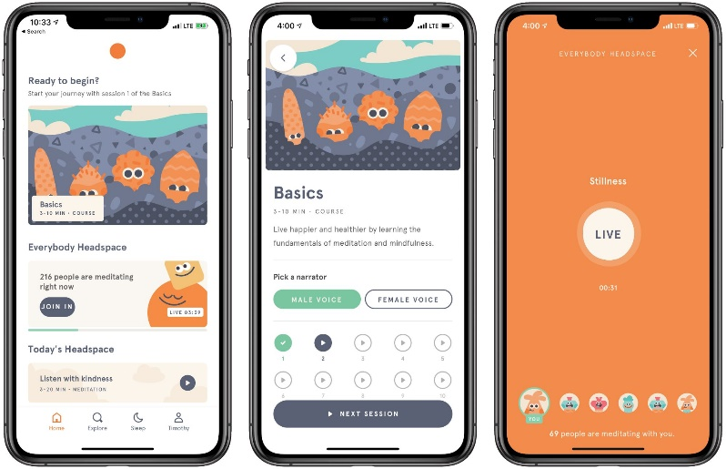

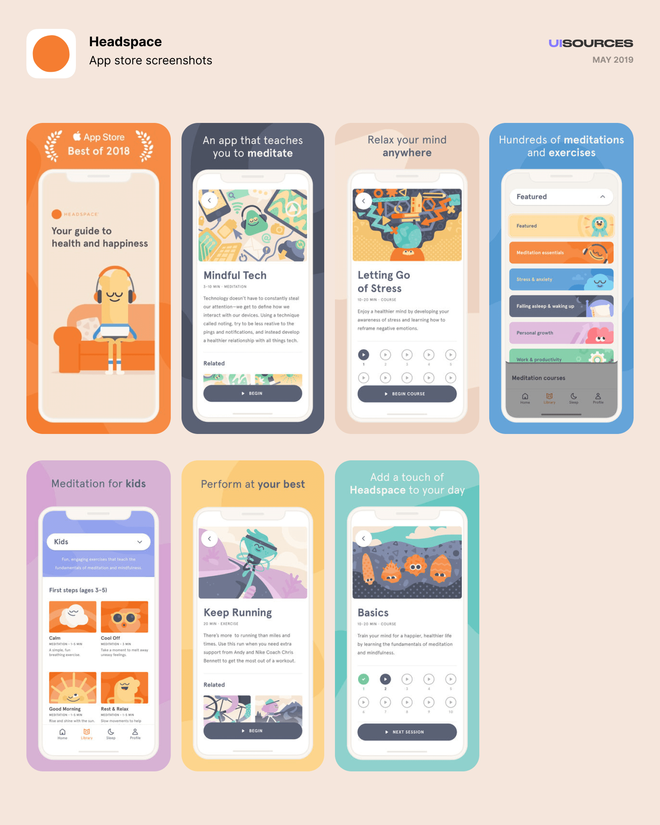

**Calm:**

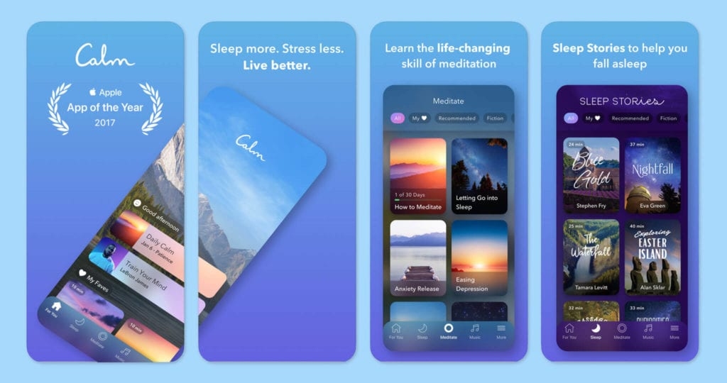

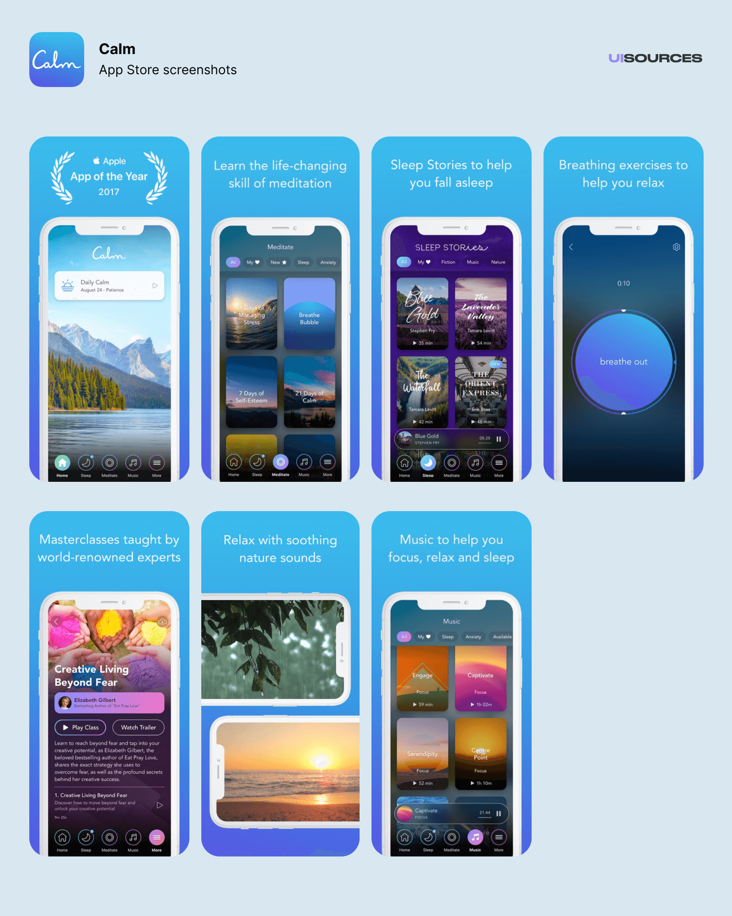

**Happify:**

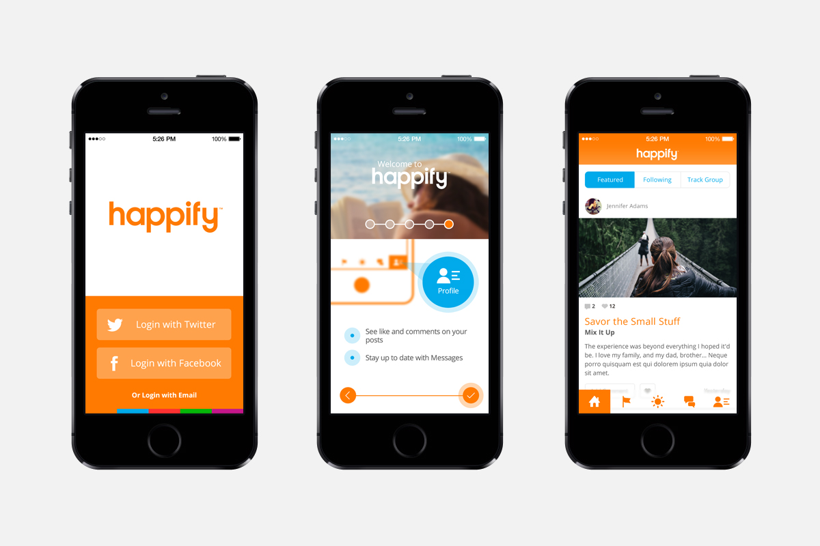

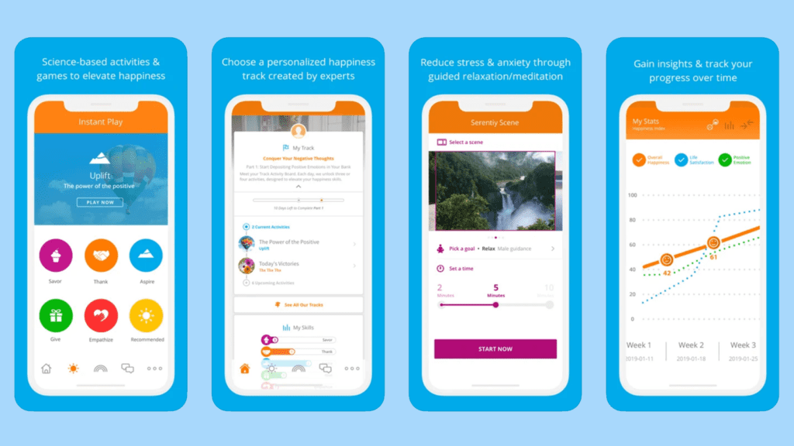

**B.2 Observations and Learnings:**

Through this experiment we learnt that interview methodology aims to better understand what consumers are looking for and to build better products that incorporate those qualities and combine evidence-based practices that will result in building effective and desirable product. Furthermore, understanding how people search for apps and what influences their decision to use an app may be helpful in presenting information about apps in persuasive ways to drive uptake and long-term use. Through this comparison, we were able to comprehend the strengths and shortcomings of the three apps as well as the factors that led to their commercial success.

**B.3: Conclusion:**

We compared pre-existing apps in the same domain through this experiment. We considered both their strengths and weaknesses. To learn what our target audience's users enjoy and dislike, we conducted user interviews and asked questions to get insightful information about our users. Using the data from the comparison analysis, we aim to develop a user-centric design. With this, we started our ideation and brainstorming process using the analyses and interviews for our website, keeping in mind our users' convenience and provide them with better and improved experience.